Get to Know: Studios

Studios Inter-Op Training for ATDs

**Table of Contents**

Supporting Information 3

Introduction 3

Topics Covered 3

Tools Used 3

Base Topology 3

Example Files and Script 5

Repository 5

Tagman Script 6

ATD Environment 7

Creating an ATD 7

Accessing the ATD 8

Sanitizing the ATD 9

Testing a Deployment 9

Using Tags with the Tagman Script 11

Adding Tags 11

Deleting Tags 11

Onboarding Devices 12

Importing Studios and Inputs 13

Enable Import of Inputs 13

Import a Studio 13

Import Studio Inputs 14

Configuring and Submitting Studios 15

Creating Workspaces 15

Assigning Tags 16

Submitting Workspaces 17

Approving and Executing Change Control Operations 19

Examples 21

Example One: Campus Network to ISP 22

Example Two: Campus to Campus EVPN 26

Example Three: Campus iBGP Underlay 30

Example Four: BGP DC Interconnect 34

Example Five: OSPF on DC Border Leaf 37

Example Six: DC Border Leaf OSPF per VRF 40

Example Seven: eBGP Routed Enterprise 43

Example Eight: Campus Switch Stacking 46

Example Nine: EVPN eTree IPv6 Underlay 50

# Supporting Information

This section contains information to support you in completing the examples. It provides an explanation of the tools used and the necessary workflows you will complete.

The examples reference the information given here, so you can complete the examples without reading through the supporting information.

## Introduction

This document contains several use case examples for understanding how to leverage Studios to meet current customer needs. Each example uses multiple studios to deploy complex networks, and the configuration for each deployment is provided. Once deployed, the example networks can be tested to demonstrate functionality.

## Topics Covered

1. Loading and deleting tags through the API
2. Working with Studios github repository
3. Importing custom Studios, cloning Studios
4. Turning on Alpha features
5. Import and export of inputs files
6. Combining Roles on devices to inter-connect them
7. Editing Studios UI schema
8. eBGP and policy
9. Protocol redistribution
10. Building EVPNs over DCs and a routed Campus
11. Configuring virtual switch stacks
12. OSPFv3 and IPv6
13. Editing Studios templates
14. Getting the latest built-in Studios from the CloudVision repo

### Tools Used

The examples and their configuration are provided through GitHub. You will be able to import each studios configuration and upload tags using a script, tagman.py, provided in the repository. This means that minimal time will be required to configure the studios.

You’ll use an Arista Advanced Routing ATD for these examples, which provides a CloudVision environment.

### Base Topology

Each example uses devices from the below topology, which you should familiarise yourself with:

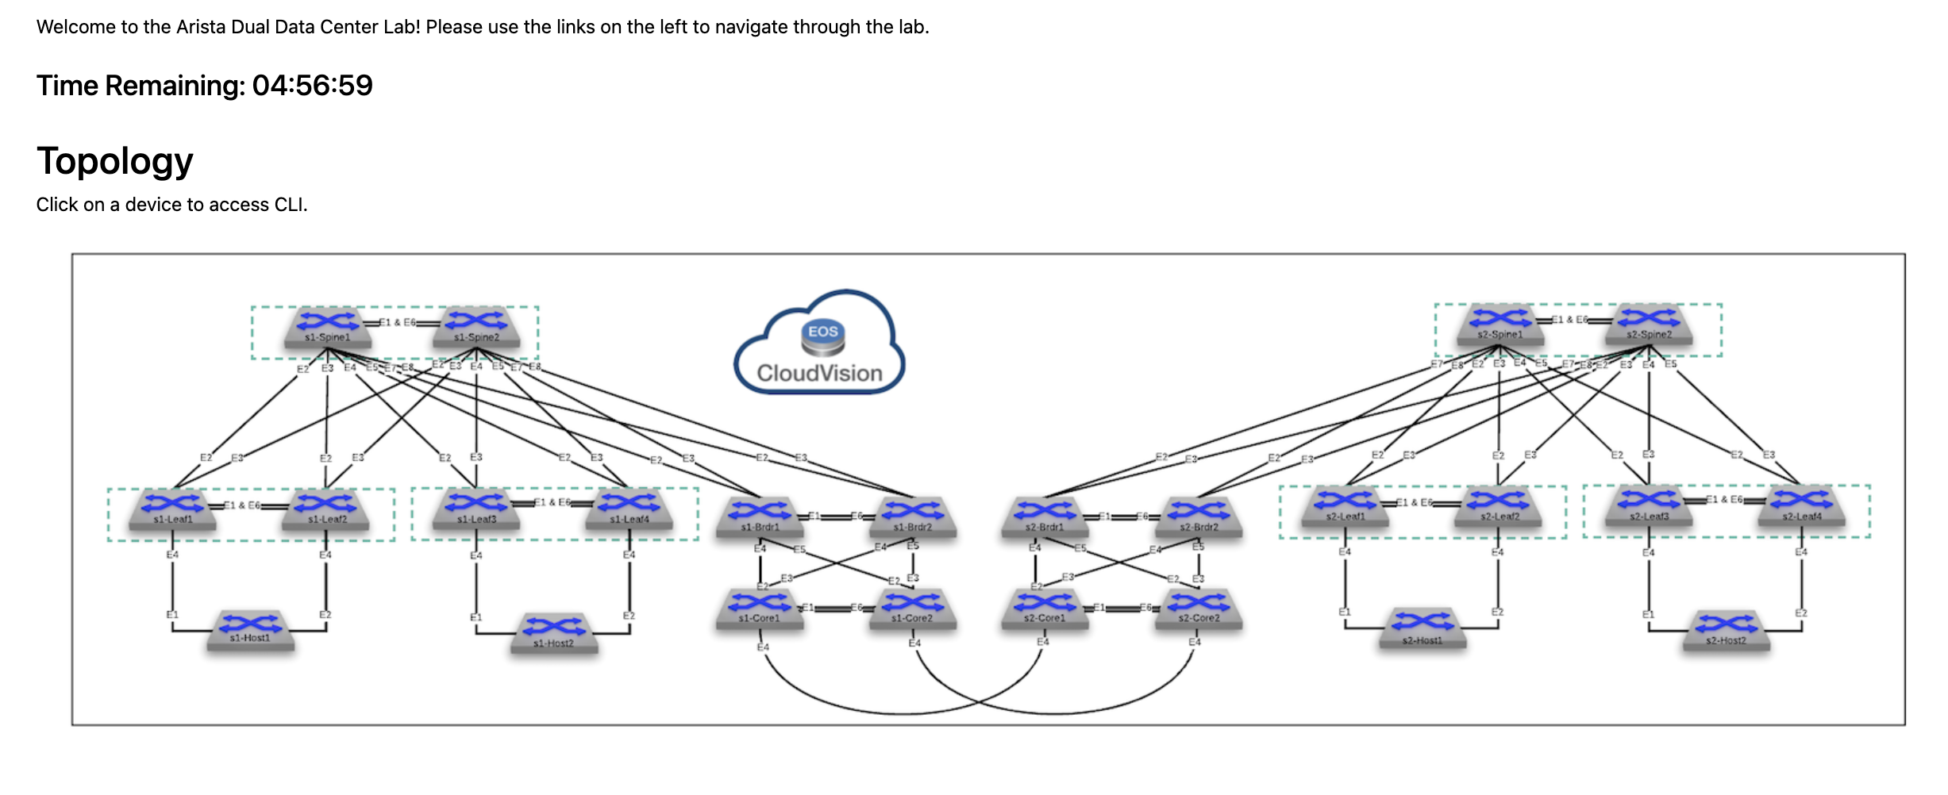

Each example has its own topology based on this, and which is provided in the instructions for the examples.

## Example Files and Script

The examples are contained in a GitHub repository and contain all of the configuration and the supporting script to successfully complete each example.

### Repository

The repository is accessible here:

<https://github.com/arista-netdevops-community/CloudVisionPortal-Examples>

The examples are contained in the following path:

CloudVisionPortal-Examples/CloudVision_Studios/InterOp_Examples_for_Studios/

The Studio versions to be used are in the CloudVisionPortal-Examples/CloudVision_Studios/InterOp_Examples_for_Studios/

/Studios_to_Use directory.

Tags Files to import are in the CloudVisionPortal-Examples/CloudVision_Studios/InterOp_Examples_for_Studios/

/Tags_Files directory.

Each Ex. X Example directory contains the inputs for each studio used in that example.



### Tagman Script

The tagman.py script, which is used to manage the tags required for each example. You’ll run this script to add or delete the tags for the examples; each example’s folder contains a .txt file, which is composed of that example’s tags.

The tagman.py script is found in CloudVisionPortal-Examples/CloudVision_Studios/InterOp_Examples_for_Studios/

/Tags_Files directory.

## ATD Environment

The ATD (Arista Test Drive) is the environment used to configure and deploy these examples. With it, you’ll be able to import the necessary tags and configuration for each example and sanitize the environment when finished.

The ATD has two states: Running and Shut Down. Typically, an ATD runs for 8 hours and then shuts down. You’ll need to start the ATD once it has shut down, and it can take 10 minutes for CloudVision to restart.

You can sanitize your ATD environment using the tagman.py script found in the repository.

### Creating an ATD

You’ll deploy a new ATD when you want a new environment to configure and deploy these examples inside. It is not necessary to create a new environment for each example; you can sanitize the environment when finished.

1. Visit <https://testdrive.arista.com/>
2. Login

**Note**: You may need to request access to this service if you are unable to login

1. You’ll be brought to the Administration screen, where you should configure a new ATD in the following way:



1. Click **Submit** and the new ATD will be deployed

You’ll receive an email with the access tokens, and can now access this ATD environment

### Accessing the ATD

When an ATD has been created, you’ll receive access tokens to enter the environment and it will start automatically. Typically an ATD will run for 8 hours before shutting down, and if it has shut down you’ll need to restart it. The starting process can take 10 minutes.

1. Access the ATD via its access token
2. You’ll then be brought to the ATD’s management page, where you can start, shut down or access the topology



If the status reads **Your topology is currently: Shut down** click **Start**

1. Click **Click Here to Access Topology** and you’ll be brought to the configuration screen



You may need to scroll down to see all the relevant information.

1. This shows the time remaining on the ATD before it shuts down and needs to be restarted
2. This shows the status of CloudVision. If it does not state “currently UP”, you will need to wait until it does so – CloudVision is still loading
3. These are your login credentials for accessing this ATD’s CloudVision instance
4. Click here to access the instance’s version of CloudVision
5. Click on **CVP** to access CloudVision and login using the lab credentials

### Sanitizing the ATD

You’ll sanitize and ATD using the Tagman script to remove the tags applied for the example, and you’ll also remove any Device Selections made during the studio.

1. Run the tagman script with the delete command
2. Delete the top-level inputs in each configured studio



1. Confirm that the tags have been deleted. Enter Tags and check the box “Select All” 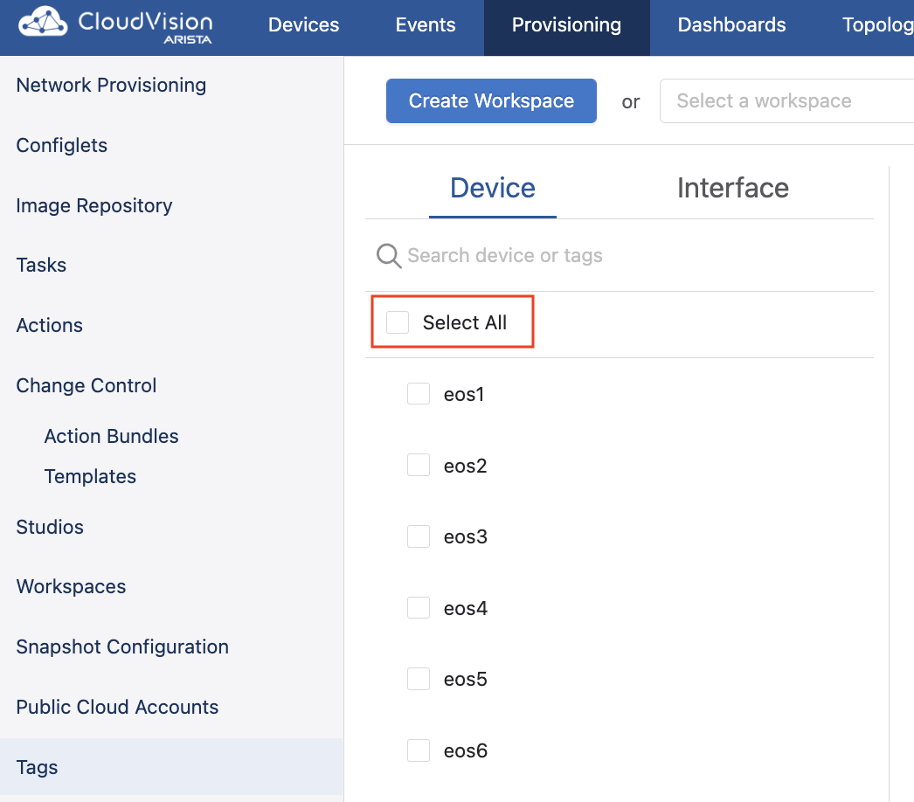
2. Confirm “No tags assigned” is indicated. 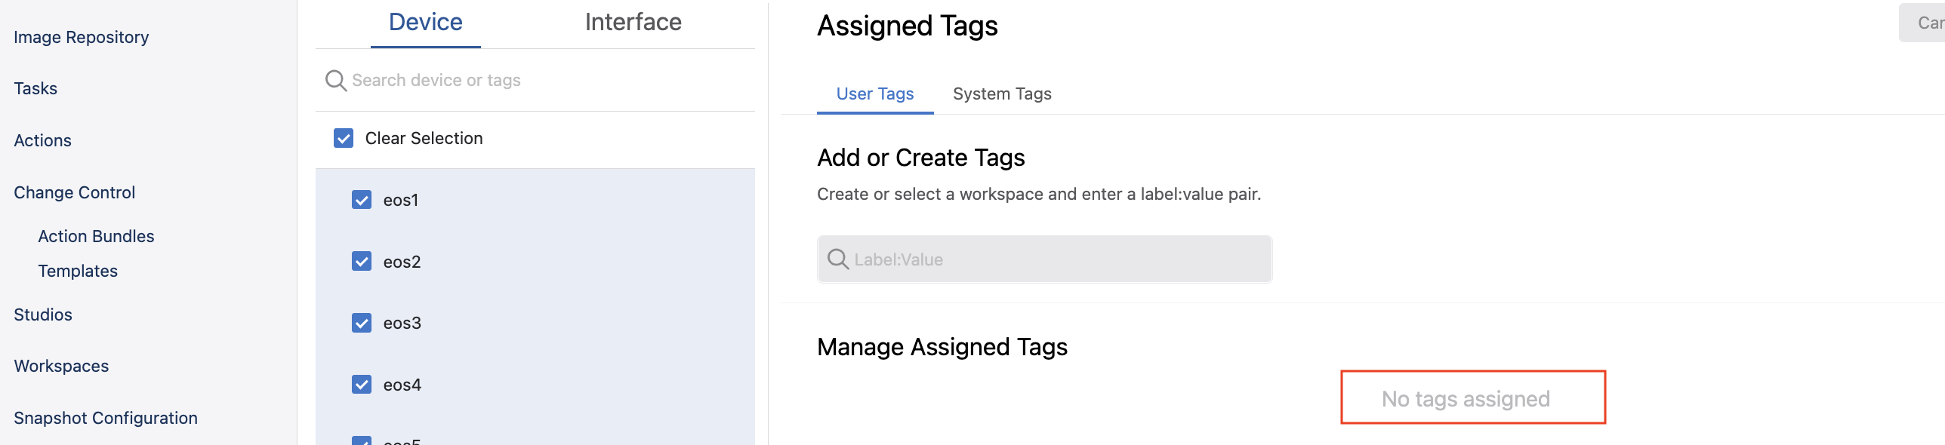
3. Device selection box can remain set to All Devices 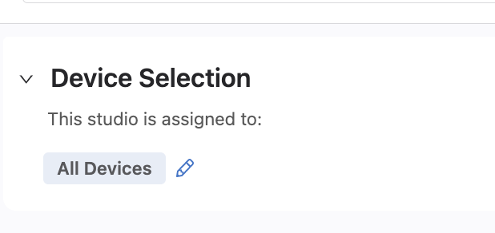

The ATD is now sanitised and you can begin importing tags for a new example, and configuring the studios required for that example.

### Testing a Deployment

On the configuration screen, you will be able to access a CLI for each device in the topology.

Click on a device in the topology to access its CLI. Use the lab credentials of your ATD to log into the device’s CLI.



## Using Tags with the Tagman Script

A python script, tagman.py, is provided with the repository. This can be used to add and delete the required tags for each example quickly.

A specific file, tagsfile.txt, is provided with each example that can be exported to the ATD using tagman.py.

The syntax of the command to run the script is:

|  |
| --- |
| $ python tagman.py -u [ATD username] -p [ATD password] -c [ATD DNS without preceding “https://” and trailing “/”] -f [the example tagsfile.text] -a import |

**Note**: Any open workspace in the ATD will be unaware of any changes to tags you make with tagman.py. You will need to create a new workspace after running any of its commands.

You can check the status of the tags on the ATD in the Tags section of Provisioning.

### Adding Tags

To add tags for a given example, you’ll append -o add to the command, like in the example below that adds Example 1 tags:

|  |
| --- |
| $ python tagman.py -u arista -p arista4f2k -c unf-1-d2c4af25.topo.testdrive.arista.com -f tagsfile-example1.txt -a import -o add |

### Deleting Tags

To delete tags, you’ll append -o delete to the command, like in the below example that deletes the Example 1 tags:

|  |
| --- |
| $ python tagman.py -u arista -p arista4f2k -c unf-1-d2c4af25.topo.testdrive.arista.com -f tagsfile-example1.txt -a import -o delete |

## Onboarding Devices

Devices need to be onboarded to the Studios environment in order for configuration to be pushed to them. If you do not onboard the devices, any configuration created and subsequently executed in Change Control will not be applied to the devices.

1. Create a Workspace and enter Inventory and Topology
2. Click the **Updates** tab and click **Add All New Updates**



1. Click **Review Workspace**
2. Submit the workspace

The devices are now available to be provisioned by Studios and configuration can be pushed to them.

## Importing Studios and Inputs

The studios and inputs required to complete the examples are available for import in the CloudVision_Studios folder of the cloned repository.

### Enable Import of Inputs

1. Visit General Settings in Settings
2. Press ctrl + A to reveal the alpha settings



1. Scroll to the bottom of Features and enable Studios Alpha Features



You’ll now be able to import Studio inputs.

### Import a Studio

1. Visit Studios
2. Create a workspace
3. Click **Import**



1. In the Import mode, navigate to the Studios_to_Use directory in the repository.
2. Select each studio and import them all. Which specific studio to use is specified within each example.
3. Click **Upload**
4. Make a clone of the L3LS Studio. We will use this clone in the course so we can make modifications to it later.

The Studios will now be available to configure.

### Import Studio Inputs

1. You need to access the studio that you want to import the inputs into
2. Within the studio, click the **ellipsis** beside Edit



1. Select **Import** under Inputs and navigate to the inputs file in your folder
2. Click **Upload**

Once you have done this, the studios will include the configuration.

## Configuring and Submitting Studios

The vast majority of the configuration required to successfully deploy these examples is imported. You will, however, need to do some basic configuration and complete the essential workflows of Studios.

More information on using Studios can be found [here](https://docs.google.com/document/d/1Hsib-Ox-ycp1iTPiuzKY7Om8ve7Ej_d1FOWeAWhAju4/edit).

### Creating Workspaces

A workspace is an instance used to record and build configuration changes you make in Studios. You’ll need to create a workspace to import studios and inputs, to onboard devices, and to configure studios. You can complete these examples with one workspace or you can use multiple workspaces.

1. Click **Create Workspace**, which will bring up the Create New Workspacemodal. You can do this within Studios:



1. Give your new workspace a name and a description, and then click **Create**



The Workplace you’ve created can now be used to manage the configuration of one or more studios. It will be available for use in the workspace dropdown menu.

### Assigning Tags

Tags identify the devices a studio will configure and are used in inputs. You’ll need to assign tags to any studios that you configure so that configuration can be pushed to those devices.

Within each studio, with the exception of Inventory and Topology, there is a Device Selection option.



You’ll use Device Selection to specify the devices that any given studio’s configuration affects. All of the tagged devices you select must already have been onboarded for use in Studios with the [Inventory and Topology Studio](https://docs.google.com/document/d/1Hsib-Ox-ycp1iTPiuzKY7Om8ve7Ej_d1FOWeAWhAju4/edit#heading=h.9swfxqanlo73). In order to assign devices, click **Set Tag Query** and then enter a device tag query.



You can edit these tagged devices at any point with a workspace by clicking the pencil icon to the right of the last tag.

You can use tags to apply an entire studio to a selected group of devices. For example, you may want the configuration of a studio to relate only to devices in a particular data center. All devices in that data center can be tagged under a label, and you can assign that studio to that tag label.

When adding multiple items with the same label (the part of the tag to the left of the colon) use a Comma “,” on your keyboard to open a new drop-down list and click the next device. When adding items that have different labels, type “or” in the Device Selection Box and then select “OR” from the drop-down list. Notice the commas and OR in the example below.



### Submitting Workspaces

You’ll submit workspaces to Change Control in order to push a workspace’s configuration to devices. The workspace’s configuration is then approved and executed in Change Control.

1. Click the **Review Workspace** button in the header



1. The workspace will be automatically built for submission, which includes input validation, compiling the configuration, and the validation of the configuration. On the Build screen, you’ll be able to [review the proposed configuration changes](https://docs.google.com/document/d/1Hsib-Ox-ycp1iTPiuzKY7Om8ve7Ej_d1FOWeAWhAju4/edit#heading=h.1x0gk37)

**Note**:The workspace is automatically built only for the first time that you click ReviewWorkspace. Any subsequent changes made after that will require that you re-build the workspace by clicking **Start Build**.

1. Once satisfied, you can click **Submit Workspace**



1. You’ll be presented with a modal that will bring you to Change Control



A change control operation will now be created and you can approve and execute this in Change Control.

**Note**:Not all workspace submissions will create a change control operation. The View Change Control button will be disabled when no configuration changes have been created, but any other changes will come into effect.

### Approving and Executing Change Control Operations

Once a workspaces has been submitted, it creates a change control operation that must be approved and executed. When executed, the configuration submitted by the workspace is pushed to the devices.

1. Click **Review and Approve**



1. You’ll now see a modal that displays a summary of the configuration changes, which also allows you to add a custom note to the change control



1. Toggle on **Execute Immediately** and click **Approve and Execute**

The change control operation will now begin to execute and its configuration will be pushed to devices.

# **Examples**

Ten examples are provided showing diverse network deployments using multiple studios. These examples can be completed quickly and effectively, enabling you to understand how studios functions on a basic level and how it meets today’s networking demands.

The supporting information given above is referenced within the examples, and it is not necessary to begin with any specific example.

**Note**: You must set up an ATD in order to run and deploy these examples.

## Example One: DCI over IP Network

**Overview**

In this example,

Please look over the diagrams to get a feel for what we are about to configure.

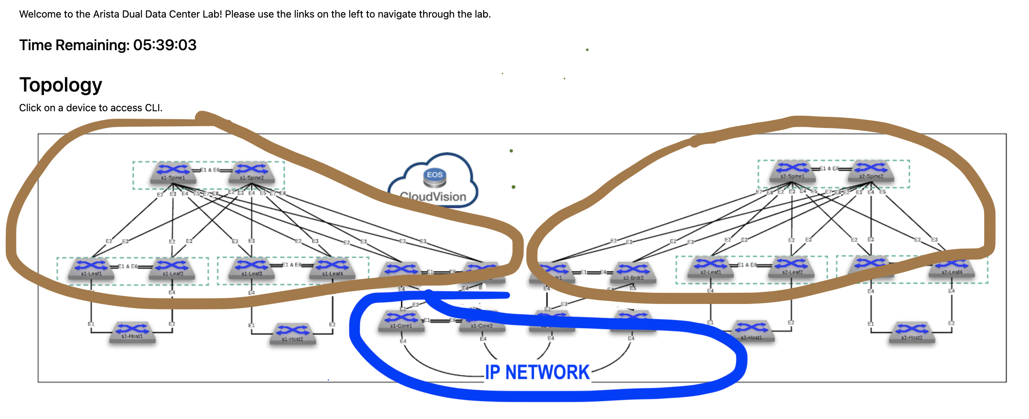

**Topology**

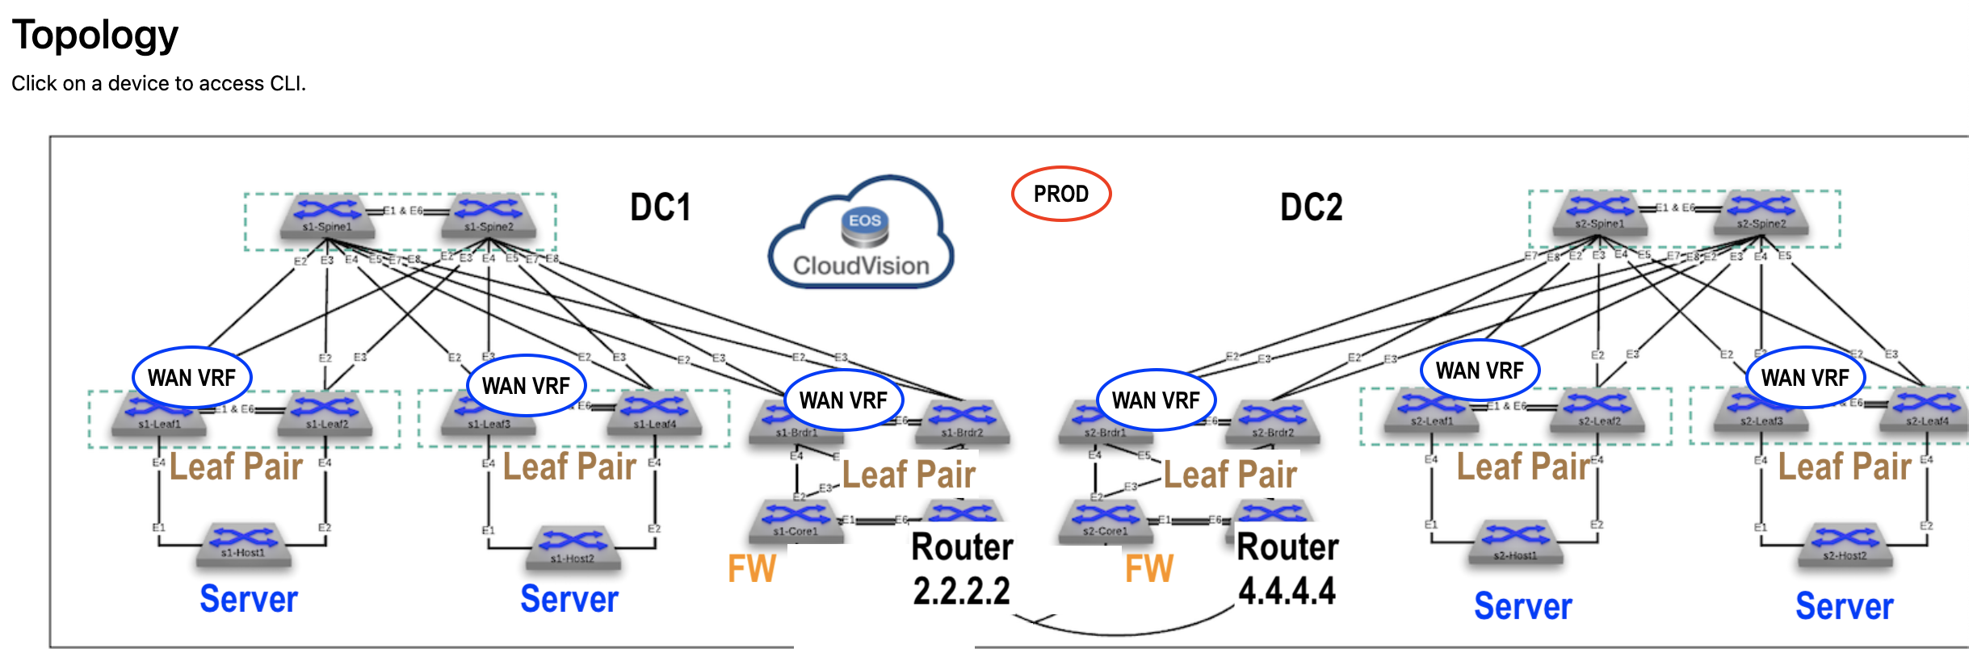

**Features**

* M

**Import**

Enterprise Routing

L3LS

**Configure**

1. Sanitize the ATD, if necessary
2. Run the tagman.py script for tagsfile-example1.txt
3. Import the Enterprise Routing and L3LS studios inputs
4. Device Selection “All Devices” for each studio

**Deploy**

You’ll now push the configuration you’ve imported to the devices:

1. Review and submit the workspace to Change Control
2. Approve and Execute the change control operation

**Review**

Please review

**Test**

Use

* From

**Task**

#1 Goal

**Test**

Use the

**Extra task**

#1 Goal – Lea

## Example Two: DCI over EVPN IP Network

**Overview**

In this example,

Please look over the diagrams to get a feel for what we are about to configure.

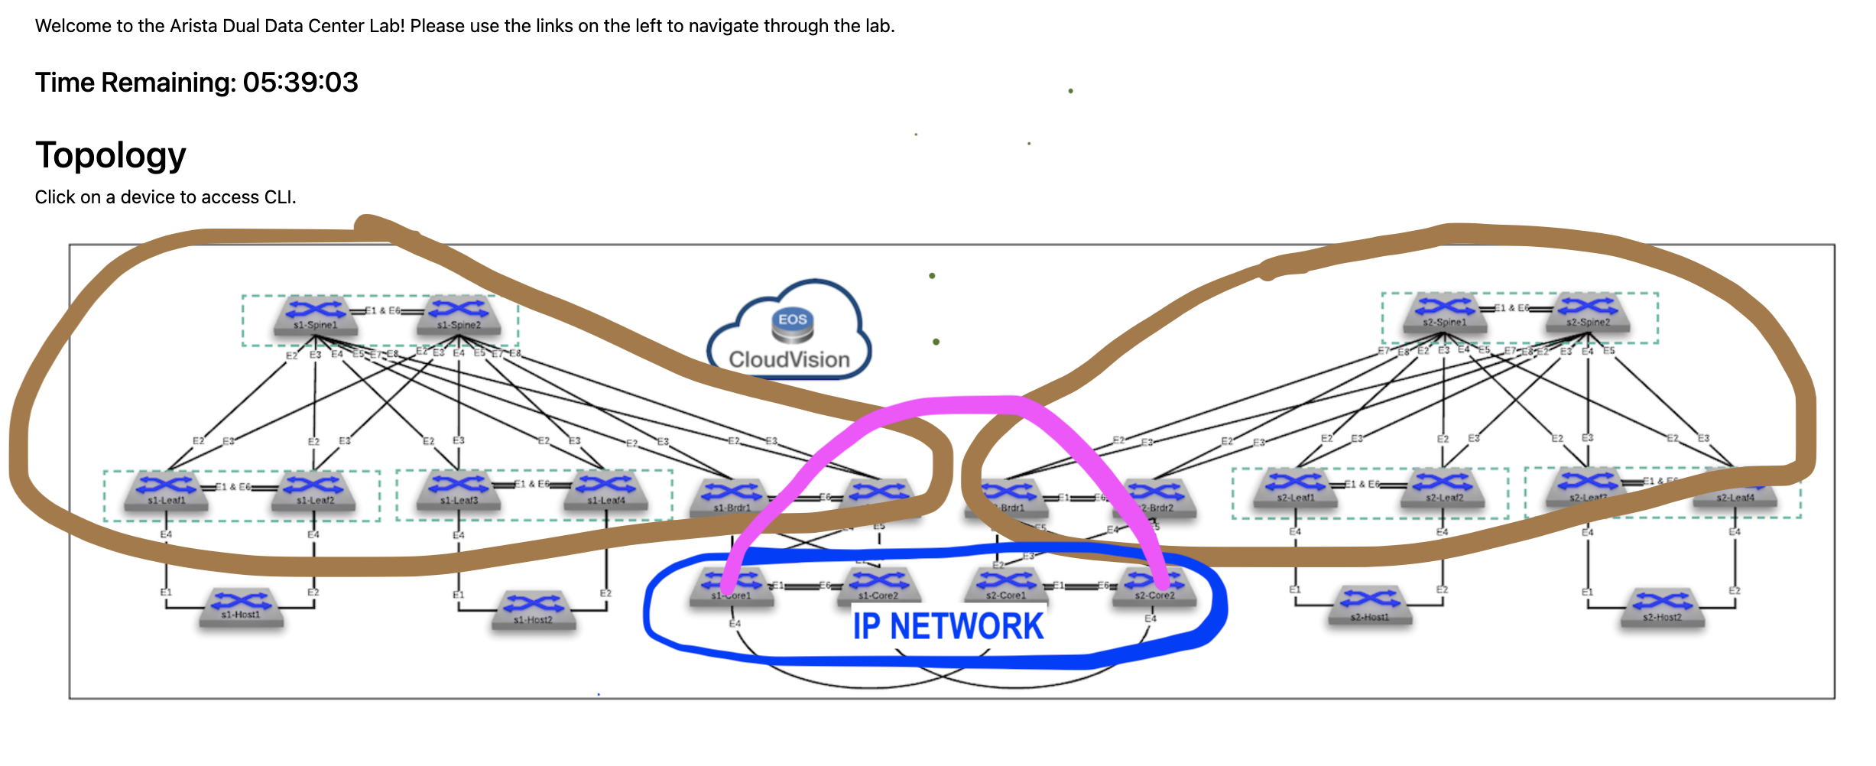

**Topology**

**Features**

* L2 EVPN o VXLAN
* L3 EVPN o VXLAN

**Import**

Enterprise Routing

L3LS

**Configure**

1. Sanitize the ATD, if necessary
2. Run the tagman.py script for tagsfile-example1.txt
3. Import the Enterprise Routing and L3LS studios inputs
4. Device Selection “All Devices” for each studio

**Deploy**

You’ll now push the configuration you’ve imported to the devices:

1. Review and submit the workspace to Change Control
2. Approve and Execute the change control operation

**Review**

Please review

**Test**

Use

* From

**Task**

#1 Goal

**Test**

Use the

**Extra task**

#1 Goal – Lea

## Example Three: DCI over MPLS Network

**Overview**

In this example,

Please look over the diagrams to get a feel for what we are about to configure.

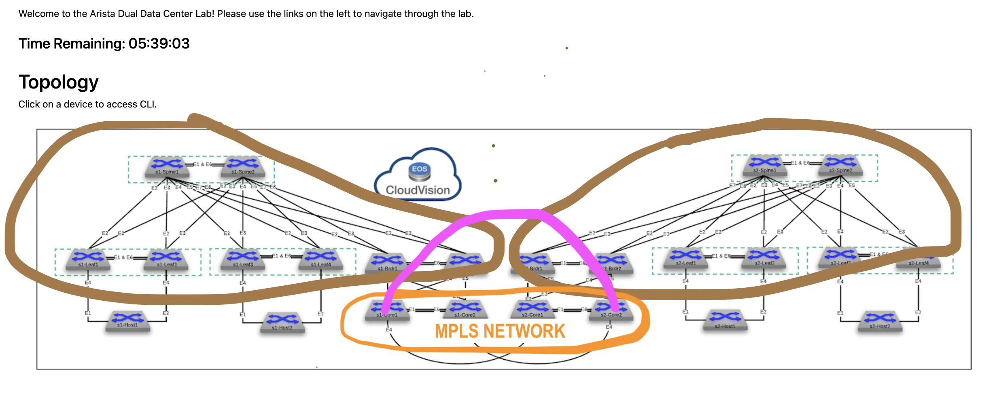

**Topology**

**Features**

* L2 EVPN
* L3 EVPN
* VPWS

**Import**

Enterprise Routing

L3LS

**Configure**

1. Sanitize the ATD, if necessary
2. Run the tagman.py script for tagsfile-example1.txt
3. Import the Enterprise Routing and L3LS studios inputs
4. Device Selection “All Devices” for each studio

**Deploy**

You’ll now push the configuration you’ve imported to the devices:

1. Review and submit the workspace to Change Control
2. Approve and Execute the change control operation

**Review**

Please review

**Test**

Use

* From

**Task**

#1 Goal

**Test**

Use the

**Extra task**

#1 Goal – Lea

## Example Four: DCI L3 EVPN Gateway over IP Network

**Overview**

In this example,

Please look over the diagrams to get a feel for what we are about to configure.

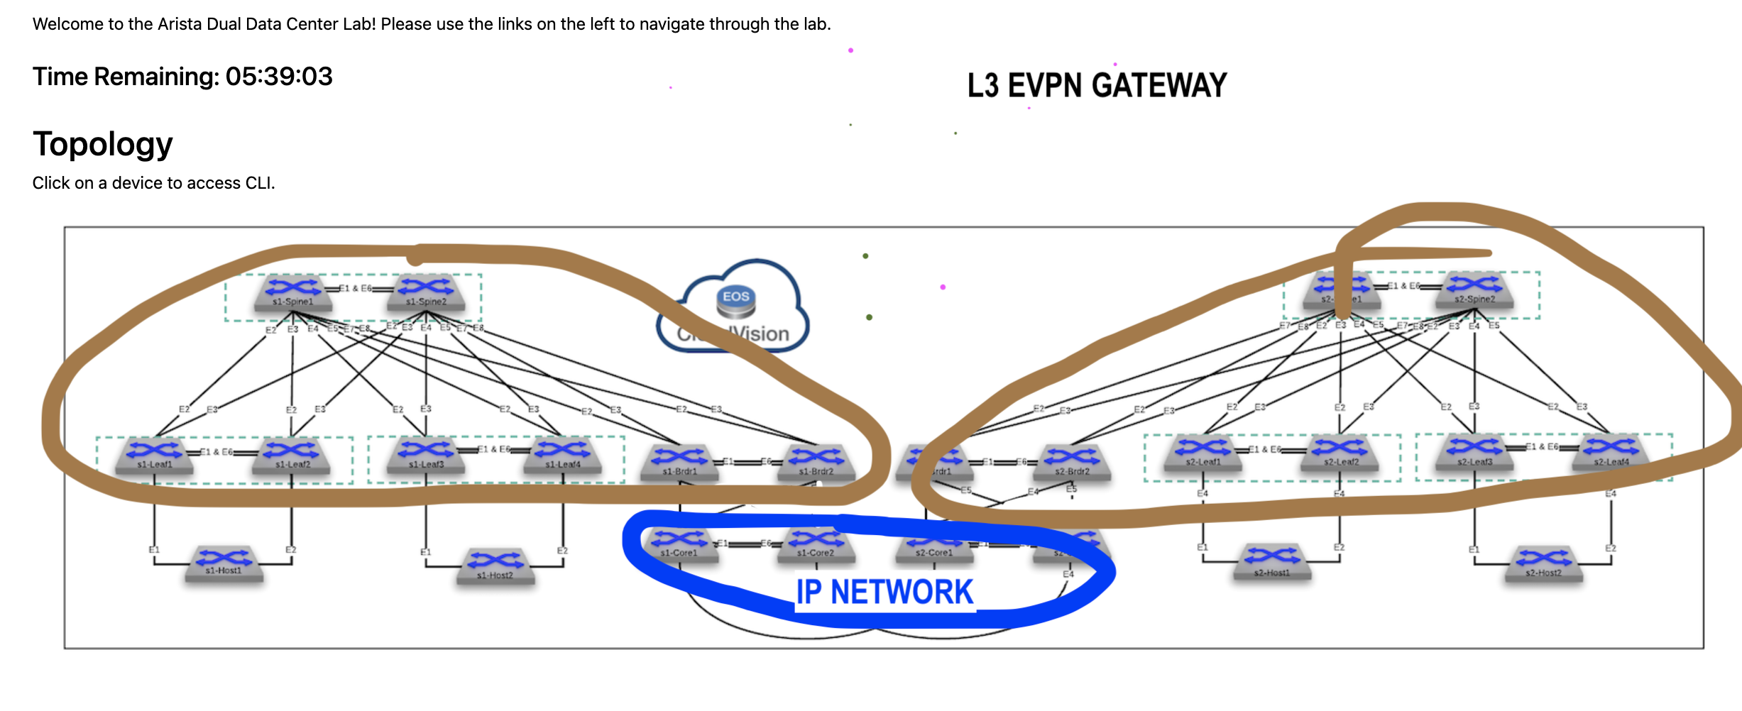

**Topology**

**Features**

* L3 EVPN

**Import**

Enterprise Routing

L3LS

**Configure**

1. Sanitize the ATD, if necessary
2. Run the tagman.py script for tagsfile-example1.txt
3. Import the Enterprise Routing and L3LS studios inputs
4. Device Selection “All Devices” for each studio

**Deploy**

You’ll now push the configuration you’ve imported to the devices:

1. Review and submit the workspace to Change Control
2. Approve and Execute the change control operation

**Review**

Please review

**Test**

Use

* From

**Task**

#1 Goal

**Test**

Use the

**Extra task**

#1 Goal – Lea

## Example Five: DCI L2 EVPN Gateway over IP Network

**Overview**

In this example,

Please look over the diagrams to get a feel for what we are about to configure.

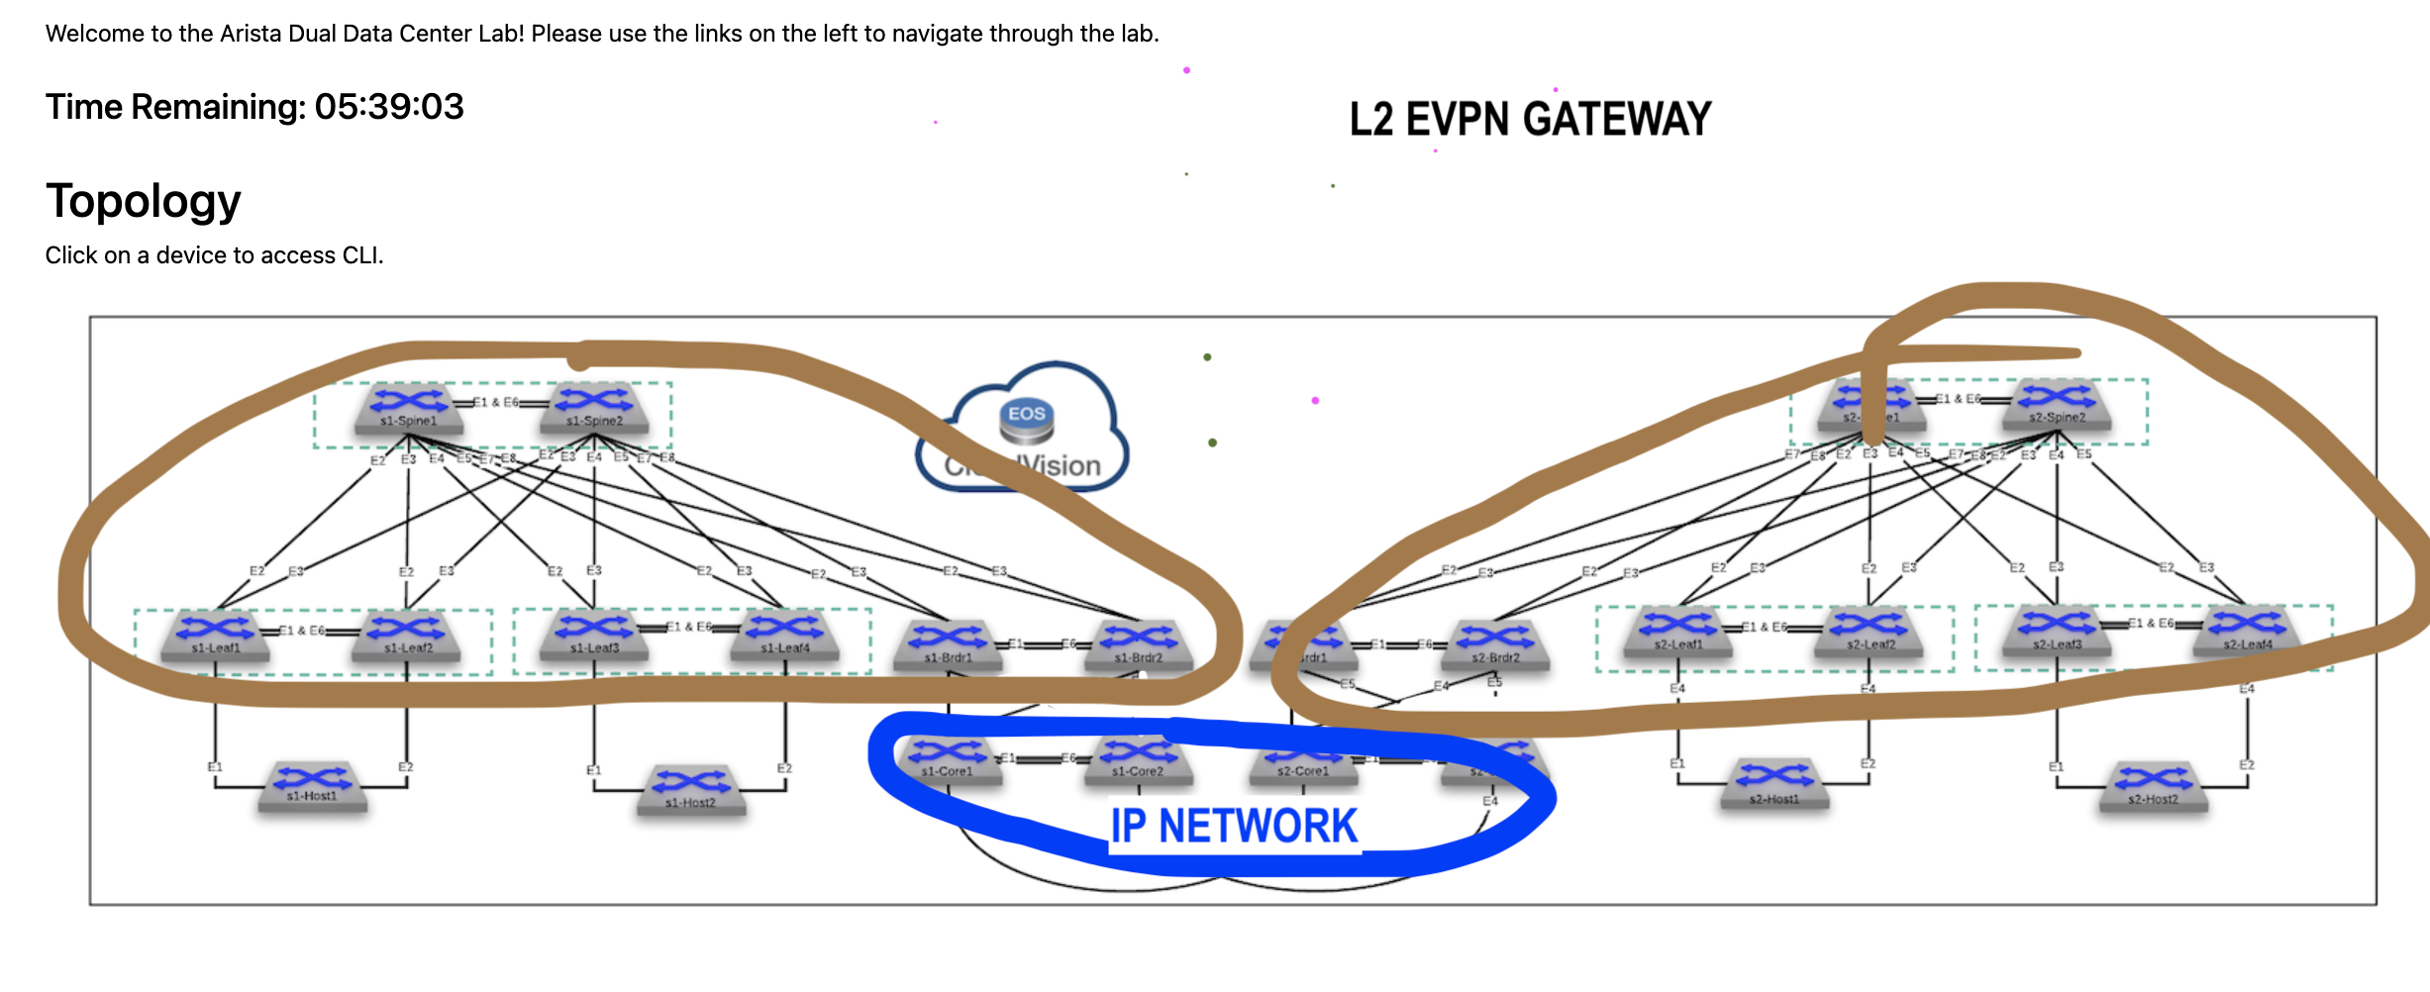

**Topology**

**Features**

* L2 EVPN

**Import**

Enterprise Routing

L3LS

**Configure**

1. Sanitize the ATD, if necessary
2. Run the tagman.py script for tagsfile-example1.txt
3. Import the Enterprise Routing and L3LS studios inputs
4. Device Selection “All Devices” for each studio

**Deploy**

You’ll now push the configuration you’ve imported to the devices:

1. Review and submit the workspace to Change Control
2. Approve and Execute the change control operation

**Review**

Please review

**Test**

Use

* From

**Task**

#1 Goal

**Test**

Use the

**Extra task**

#1 Goal – Lea

## Example Six: DCI L3 EVPN Gateway over MPLS Network

**Overview**

In this example,

Please look over the diagrams to get a feel for what we are about to configure.

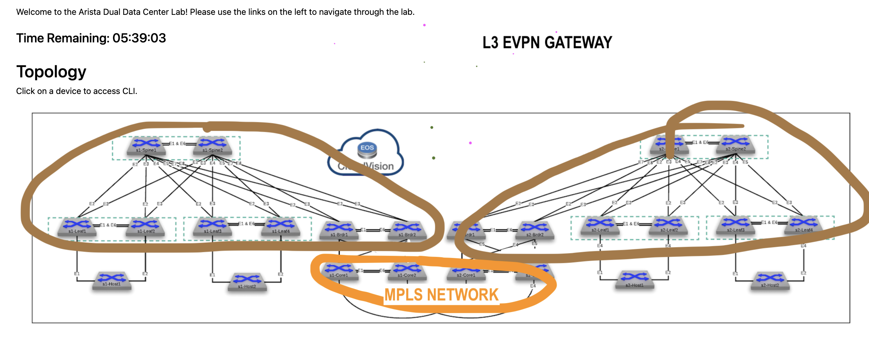

**Topology**

**Features**

* L3 EVPN

**Import**

Enterprise Routing

L3LS

**Configure**

1. Sanitize the ATD, if necessary
2. Run the tagman.py script for tagsfile-example1.txt
3. Import the Enterprise Routing and L3LS studios inputs
4. Device Selection “All Devices” for each studio

**Deploy**

You’ll now push the configuration you’ve imported to the devices:

1. Review and submit the workspace to Change Control
2. Approve and Execute the change control operation

**Review**

Please review

**Test**

Use

* From

**Task**

#1 Goal

**Test**

Use the

**Extra task**

#1 Goal – Lea

## Example Seven: DCI L2 EVPN Gateway over MPLS Network

**Overview**

In this example,

Please look over the diagrams to get a feel for what we are about to configure.



**Topology**

**Features**

* L2 EVPN
* VPWS

**Import**

Enterprise Routing

L3LS

**Configure**

1. Sanitize the ATD, if necessary
2. Run the tagman.py script for tagsfile-example1.txt
3. Import the Enterprise Routing and L3LS studios inputs
4. Device Selection “All Devices” for each studio

**Deploy**

You’ll now push the configuration you’ve imported to the devices:

1. Review and submit the workspace to Change Control
2. Approve and Execute the change control operation

**Review**

Please review

**Test**

Use

* From

**Task**

#1 Goal

**Test**

Use the

**Extra task**

#1 Goal – Lea

## Example Nine: End to End EVPN

**Overview**

In this example,

Please look over the diagrams to get a feel for what we are about to configure.

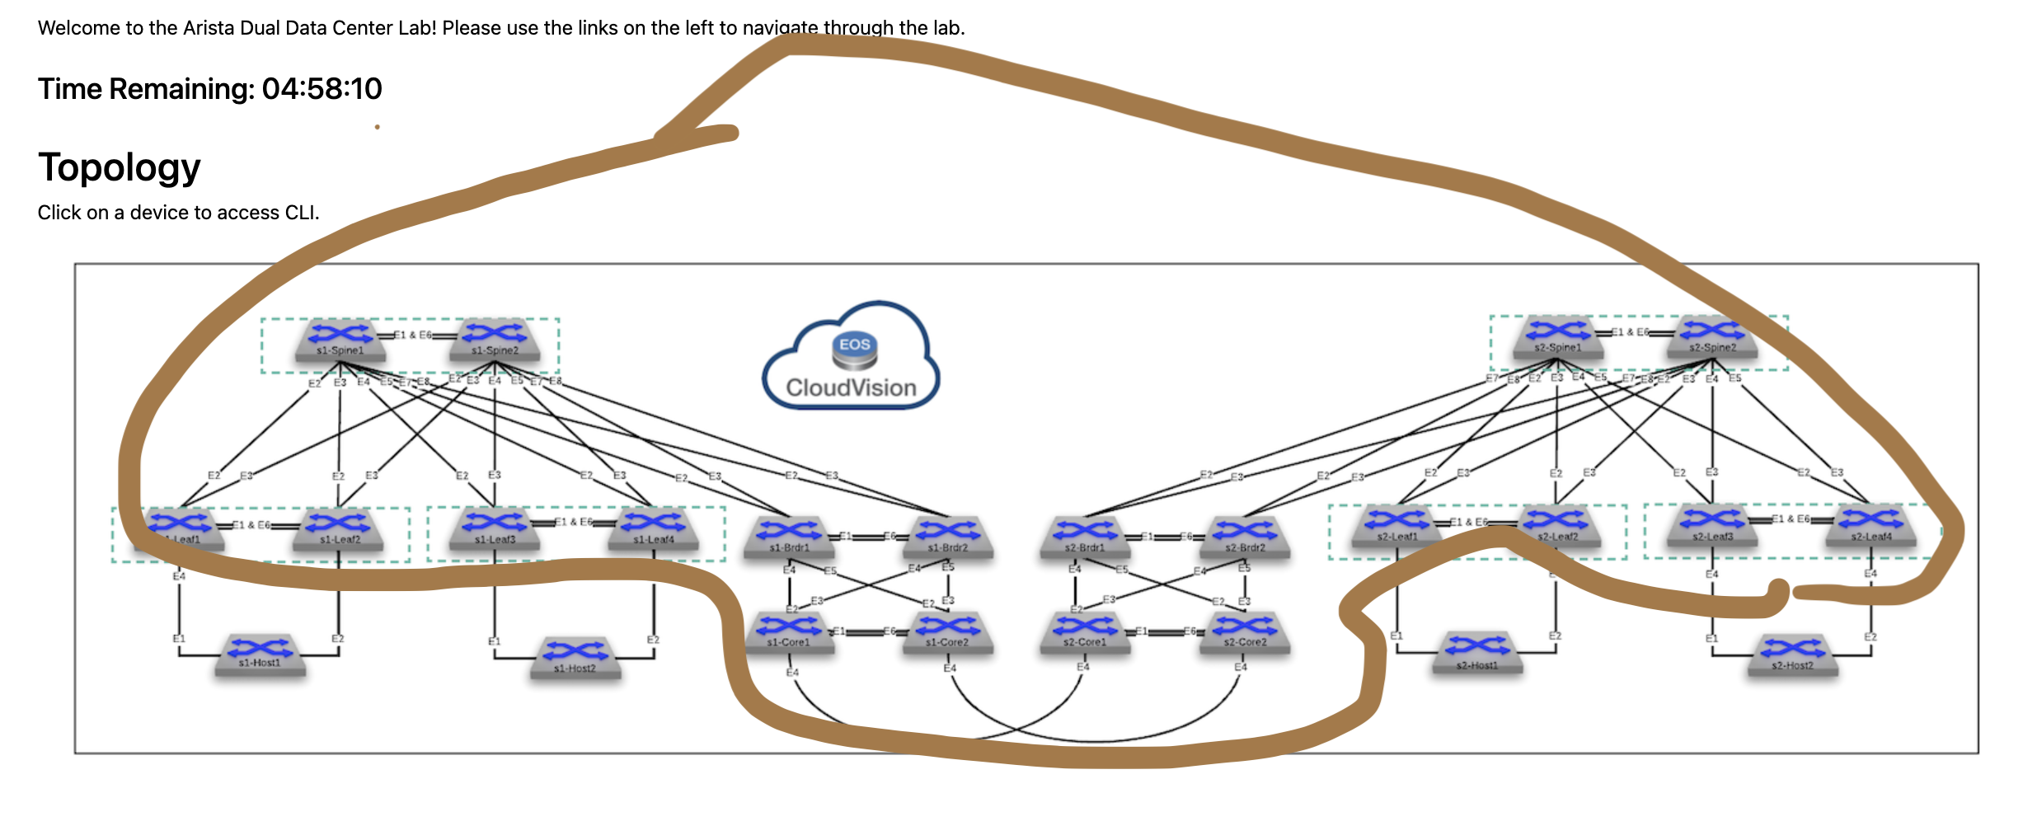

**Topology**

**Features**

* OSPF Underlay
* EBGP Underlay

**Import**

Enterprise Routing

L3LS

**Configure**

1. Sanitize the ATD, if necessary
2. Run the tagman.py script for tagsfile-example1.txt
3. Import the Enterprise Routing and L3LS studios inputs
4. Device Selection “All Devices” for each studio

**Deploy**

You’ll now push the configuration you’ve imported to the devices:

1. Review and submit the workspace to Change Control
2. Approve and Execute the change control operation

**Review**

Please review

**Test**

Use

* From

**Task**

#1 Goal

**Test**

Use the

**Extra task**

#1 Goal – Lea

## Example Ten: End to End EVPN VXLAN o MPLS

**Overview**

In this example,

Please look over the diagrams to get a feel for what we are about to configure.

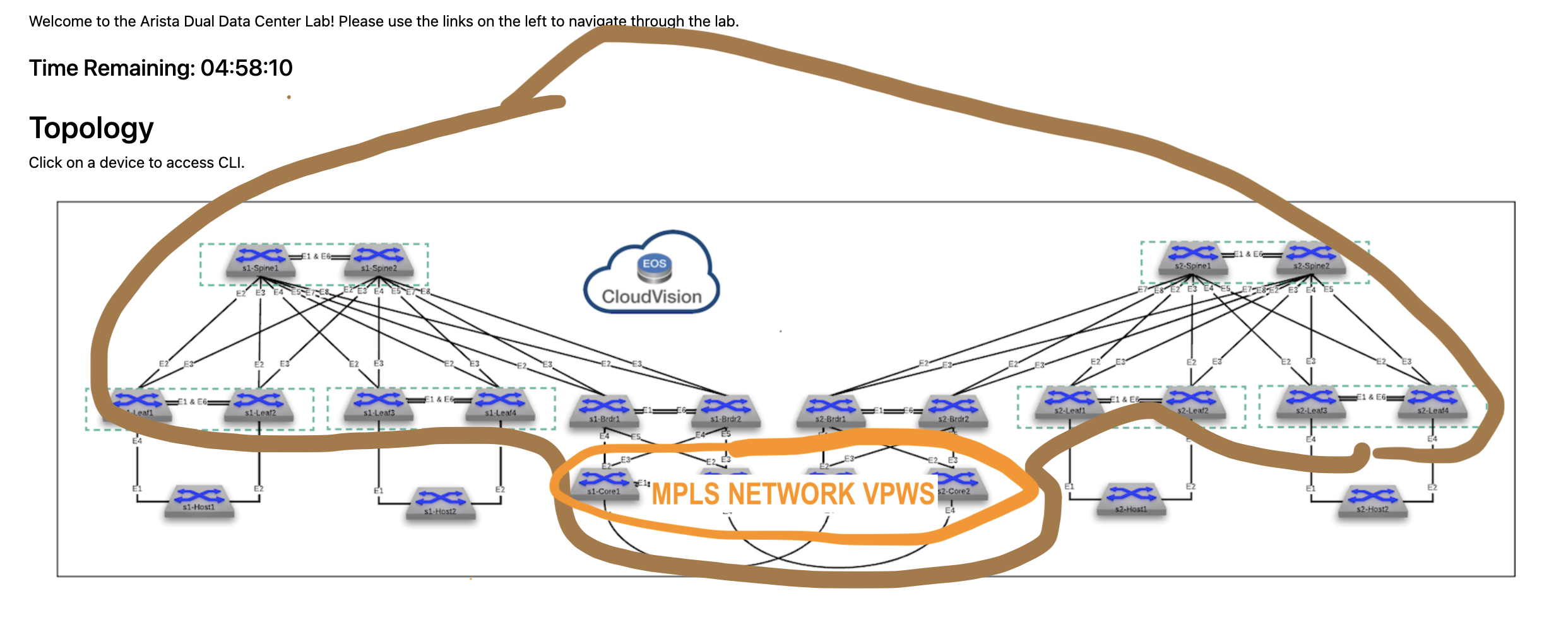

**Topology**

**Features**

* ISIS Underlay
* VPWS
* L2 EVPN
* L3 EVPN

**Import**

Enterprise Routing

L3LS

**Configure**

1. Sanitize the ATD, if necessary
2. Run the tagman.py script for tagsfile-example1.txt
3. Import the Enterprise Routing and L3LS studios inputs
4. Device Selection “All Devices” for each studio

**Deploy**

You’ll now push the configuration you’ve imported to the devices:

1. Review and submit the workspace to Change Control
2. Approve and Execute the change control operation

**Review**

Please review

**Test**

Use

* From

**Task**

#1 Goal

**Test**

Use the

**Extra task**

#1 Goal – Lea